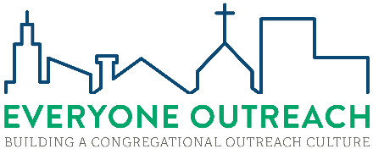
We are excited that you’ve decided to hold an EVERYONE OUTREACH workshop at your church! Before we can confirm the date for your workshop, we'll need the information below
 | Workshop Coordinator
Job Description | - Acts as congregation's Point of Contact with synod for the workshop  - Ensures workshop publicity and facilities guidelines are met, either personally or through delegation  - Provides a final roster on the last day of the workshop, using provided format
Name
Email
Phone

 | Proposed Date(s) for Workshop |  |  |  | Expected # of Participants
Example | Saturday, 21SEP24 & Sunday, 22SEP24
1st Choice
2nd Choice |  |  |  |  | Participation in the workshop must meet a minimum of 20 participants or 20% of the average weekly worship attendance, whichever is greater. (Mission congregations should shoot for 100% attendance.)
3rd Choice
Mission Congregations: |  | Check here if a mission counselor or CPI coach is facilitating the workshop.

 | Required Info | Example
Congregation Name  City, State |  | Christ Our Savior  Rockford, MI
Workshop  Location Address |  | 4610 Belding Road NE  Rockford, MI 49341
Day 1 |  | Saturday
Day 1 Start & Stop |  | 8am-noon (Notes 1 & 2)
Day 1 Meal |  | Lunch after
Day2 |  | Sunday
Day 2 Start & Stop |  | 9:40-10:40 am (Notes 1, 2, & 3)
Day 2 Meal |  | N/A
Note 1: The Everyone Outreach workshop may held on one day for 5 hours or on two days, lasting for 4 hours on the first day and 1 hour on the second day. This excludes any time for meals.
Note 2: A second session scheduled for Sunday may be placed in a standing bible study time study slot. However, this MUST BE A FULL HOUR in duration. Alternatively, it could be scheduled after the last Sunday service or bible study. Regardless of timing, we strongly recommend that only those who attended the previous 4h session attend the 1h session.
Note 3: The Everyone Outreach workshop for Mission Congregations is a single-day 4h workshop.
NEXT STEPS:
- Return this form to evangelism@wels.net.
- We'll check your proposed dates against facilitator availability and give you a tentative date for the workshop. Then you'll need to go to https://gf.wels.net/everyone-outreach/ and submit your registration fee to finalize the date.

